COMSATS University Islamabad
Attock Campus



Department Of Computer Science

Course | Information security lab
Instructor | Mrs. Ambreen Gull

Student Details

Registration No. | Name
Fa24-bse-017 | Mubashir Hussain

Question :1

Change 1 — Wrong modular exponentiation
Your power function:

return pow(a, b) % p

This first calculates huge a^b and then takes mod.
For real Diffie-Hellman this becomes extremely slow and insecure.
Python already has built-in modular exponentiation:

pow(a, b, p) # fast and secure

So we must fix the power function.

Change 2 — Wrong base case in power()

if b == 1:
return a

This is mathematically wrong for modular arithmetic.
Correct identity:

a^0 mod p = 1

But since we are using built-in pow(), we can remove the whole condition.

Change 3 — Program uses fixed private keys
Currently:

a = 4
b = 3

Real Diffie-Hellman must use random private keys.
We will use:

import random
a = random.randint(2, P-2)
b = random.randint(2, P-2)

Updated Diffie-Hellman Code

import random
# Fast modular exponentiation
def power(a, b, p):
return pow(a, b, p)
def main():
# Public values
P = 23
G = 9
print("Public prime P:", P)
print("Public primitive root G:", G)
# Private keys (random)
a = random.randint(2, P-2) # Alice private key
b = random.randint(2, P-2) # Bob private key
print("\nAlice private key:", a)
print("Bob private key:", b)
# Public keys
x = power(G, a, P) # Alice sends to Bob
y = power(G, b, P) # Bob sends to Alice
print("\nAlice public key:", x)
print("Bob public key:", y)
# Shared secret keys
ka = power(y, a, P)
kb = power(x, b, P)
print("\nSecret key for Alice:", ka)
print("Secret key for Bob:", kb)
if __name__ == "__main__":
main()

Example Output (sample run)
Every run gives different keys due to randomness.

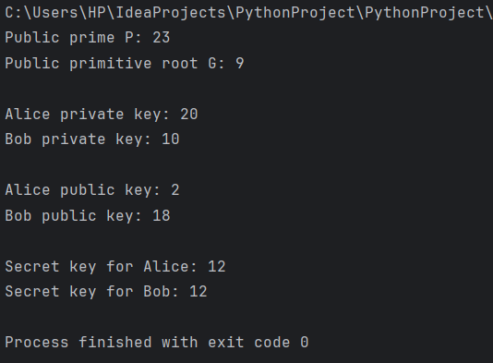

Question no: 2

Latest Attack on Key Exchange Algorithms:

Harvest Now, Decrypt Later (HNDL) Attack

One of the most recent and serious threats to key-exchange systems is the Harvest Now, Decrypt Later (HNDL) attack.

Why this attack is important
Most secure communication today uses key exchange algorithms such as:
- Diffie–Hellman (DH)
- Elliptic Curve Diffie–Hellman (ECDH)
- RSA key exchange
These are secure against classical computers, but not secure against future quantum computers.
Idea of the Attack
The attacker does NOT break encryption today.
Instead they:
- Intercept encrypted traffic (TLS, WhatsApp, VPN, etc.)
- Store the encrypted data for years
- Wait for powerful quantum computers
- Use Shor’s Algorithm to break the key exchange
- Decrypt old conversations
This is why it is called:
Harvest Now → Decrypt Later
This attack specifically threatens Diffie-Hellman key exchange.

Why Diffie–Hellman Breaks with Quantum Computers
Diffie-Hellman security depends on a hard problem:
Discrete Logarithm Problem
Classical computers:
Hard to solve → secure
Quantum computers:
Shor's Algorithm solves it fast → broken
So attackers record traffic today and decrypt it in the future.
Demonstration of the Attack in Python
We will simulate how an attacker can break Diffie-Hellman using discrete logarithm brute force
(This represents the quantum attack conceptually.)

Step 1 — Normal Diffie-Hellman Key Exchange

import random
# Public values
p = 23 # prime number
g = 5 # generator
# Alice private key
a = random.randint(1, 10)
A = pow(g, a, p)
# Bob private key
b = random.randint(1, 10)
B = pow(g, b, p)
# Shared secret
alice_secret = pow(B, a, p)
bob_secret = pow(A, b, p)
print("Public Prime p:", p)
print("Public Generator g:", g)
print("Alice Public Key:", A)
print("Bob Public Key:", B)
print("Shared Secret:", alice_secret)

This simulates secure communication.

Step 2 — Attacker Breaking the Key Exchange

Attacker knows:
- p
- g
- A
- B
They try to find private key a from
A = g^a mod p
This is the discrete logarithm attack.
# Attacker brute-force discrete logarithm
def break_diffie_hellman(p, g, public_key):
for x in range(p):
if pow(g, x, p) == public_key:
return x
# Attacker recovers Alice's private key
recovered_a = break_diffie_hellman(p, g, A)
# Attacker computes shared secret
attacker_secret = pow(B, recovered_a, p)
print("\nAttacker recovered Alice private key:", recovered_a)
print("Attacker computed shared secret:", attacker_secret)

